Report Lab 2 – CSE 422

1. Project structure:

This web will apply MVC model in ASP Dotnet Core and combine with MySQL to save and retrieve data. This web provides CRUD features for Category Model, Device Model and User Model and other features such as search devices by categoryId, device status, device name and device code.

1. Implement:

Folder Models will contain all entity which can help us to connect with MySQL.

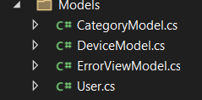

Firstly, I will create these models with attributes below:

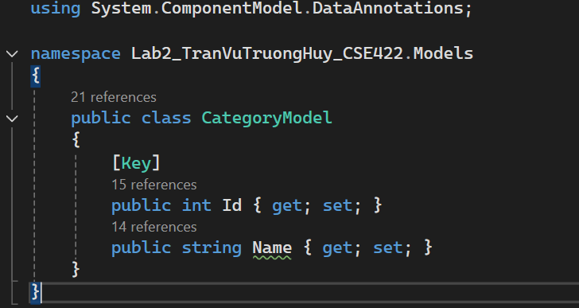

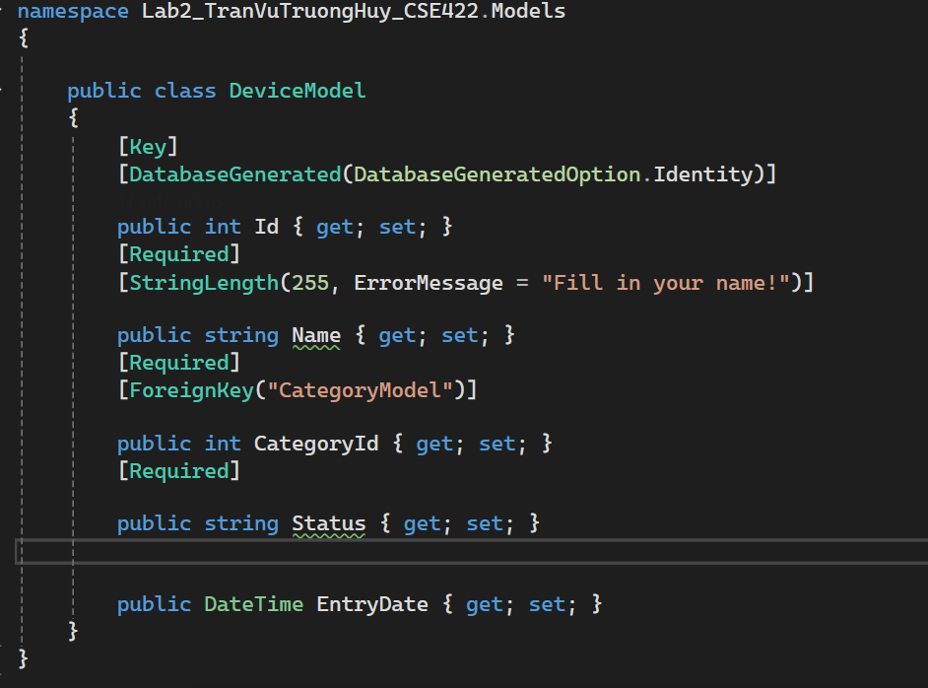

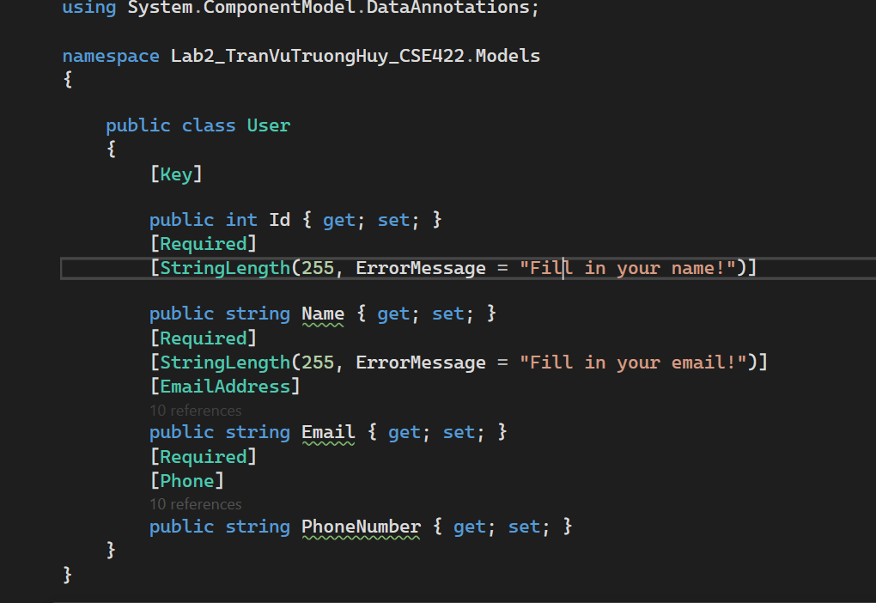

Secondly, I will connect to the database:



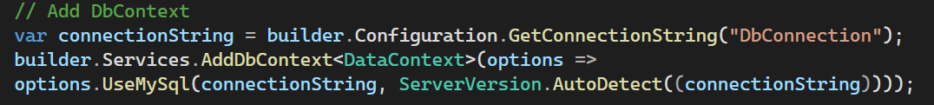

Thirdly, I will create views in folder view which will later combine with the controllers to show in the website (CRUD):

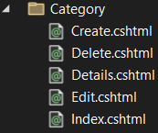 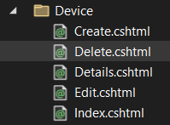 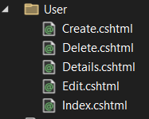

These files will contain html and C# code inside to help show data in the website and each folder will need a controller to manage the path.

Lastly, I will create controllers:

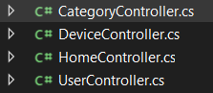 Each controller is corresponded to each view folder and it will have functions with names the same as cshtml files in view folders.

These controllers are used to define the path in url.

1. Filter features:

I will use fetch + javascript to do these feature (when people choose a categoryId, a name, a code or a status, then click on filter buttons, I will pass the parameter of it to the controller, then I will query under the database to get the list of the products and display on the website)

